Giving name as html assertion test plan

Adding thread group to the test plan

Then adding sampler🡪http request to the thread group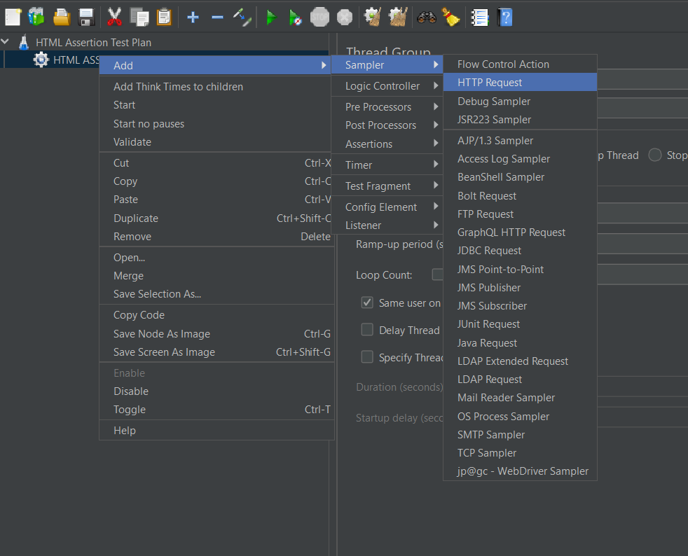

In http request ,in web server

Protocol-https

Server name-blazedemo.com, path-/

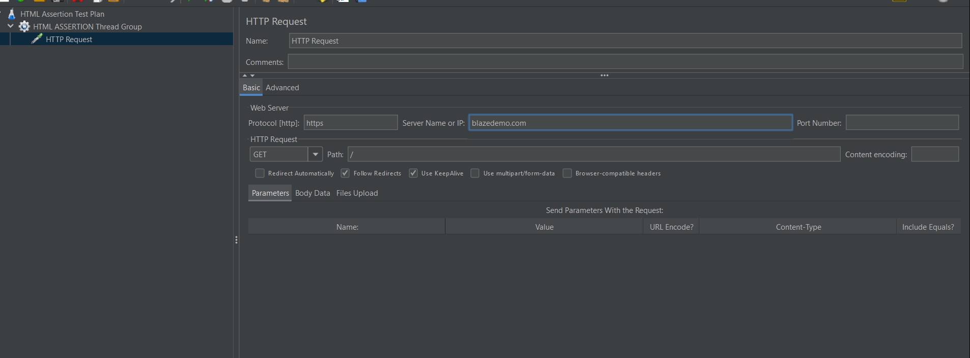

Add assertions🡪html assertion to http request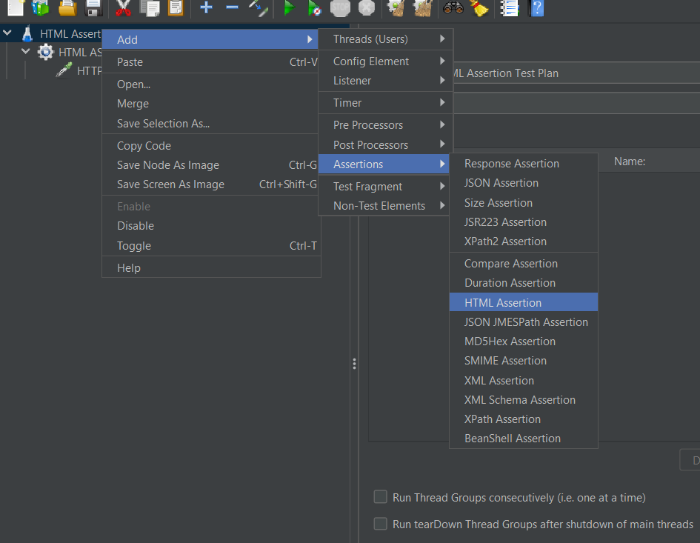

Create a folder in phase3…folder names as html warning and create a file name as error.txt

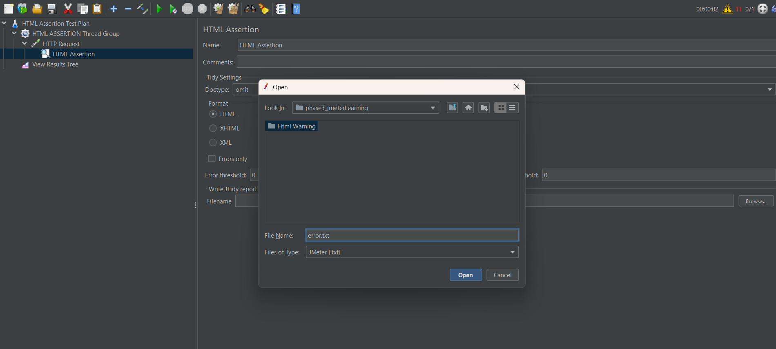

Give path in html assertion in filename box.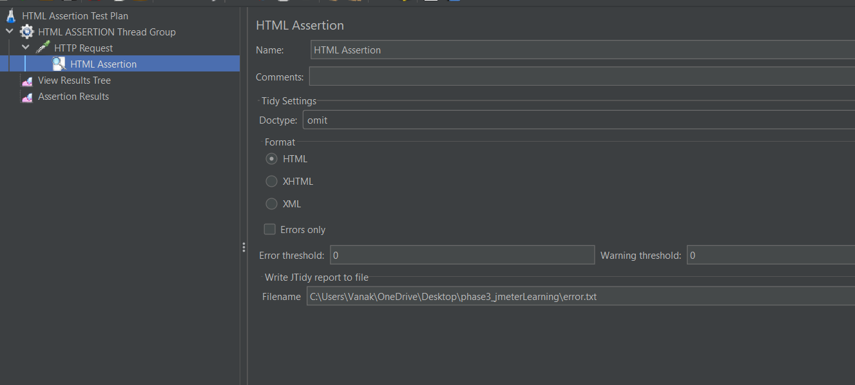

Adding assertion result in thread group

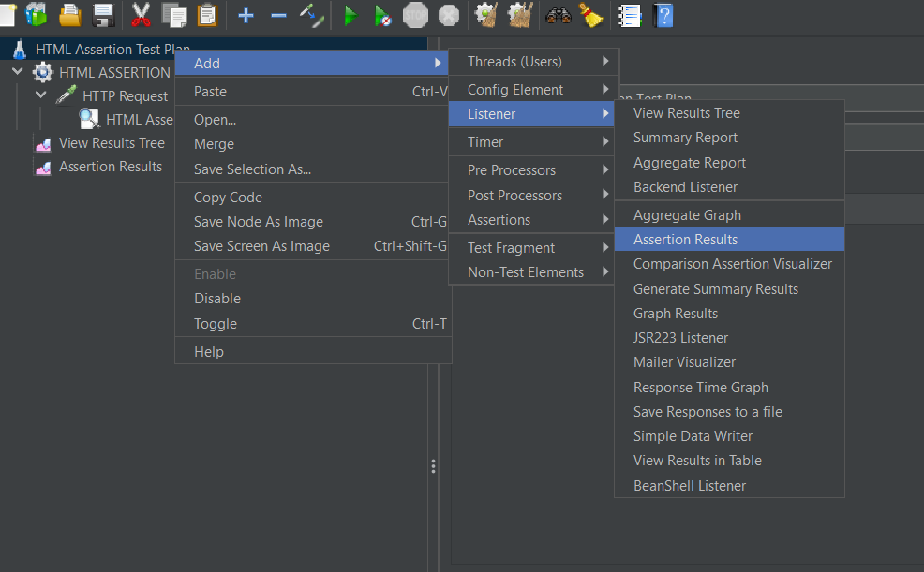

Cllick on run button